从零实现ffmpeg添加去雾filter

-- 摄像头采集图像，并通过web播放去雾后的视频流（二）
2.dehaze filter的添加与ffmpeg的安装；
2.1首先下载dehaze patch
https://github.com/awillheartwu/Streammedia-/tree/master/dehaze
可以看到其中文件内容为
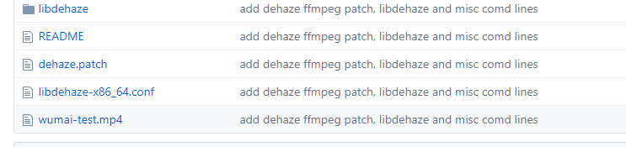
其中libdehaze为dehaze filter的依赖库，dehaze..patch则为ffmpeg的git patch，其他都在readme文件中有介绍。
2.2先编译安装libdehaze，make make install
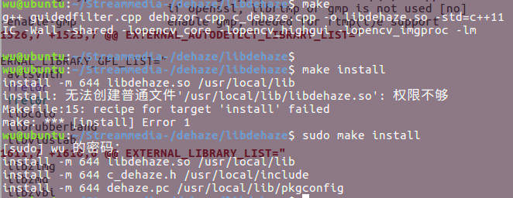
2.3 利用git apply命令安装patch
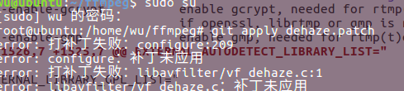
出现patch错误
参考http://www.jianshu.com/p/e5d801b936b6
后找到.rej文件直接修改

diff a/configure b/configure (rejected hunks)
@@ -209,7 +209,6 @@ External library support:
--disable-coreimage disable Apple CoreImage framework [autodetect]
--enable-chromaprint enable audio fingerprinting with chromaprint [no]
--enable-frei0r enable frei0r video filtering [no]
- --enable-libdehaze enable dehaze video filtering [no]
--enable-gcrypt enable gcrypt, needed for rtmp(t)e support
if openssl, librtmp or gmp is not used [no]
--enable-gmp enable gmp, needed for rtmp(t)e support
@@ -1526,7 +1525,7 @@ EXTERNAL_AUTODETECT_LIBRARY_LIST="

EXTERNAL_LIBRARY_GPL_LIST="
avisynth
- frei0r
+ frei0r
libcdio
librubberband
libvidstab
@@ -1611,7 +1610,6 @@ EXTERNAL_LIBRARY_LIST="
libzimg
libzmq
libzvbi
- libdehaze
mediacodec
openal
opencl
@@ -3147,7 +3145,6 @@ coreimagesrc_filter_extralibs="-framework OpenGL"
cover_rect_filter_deps="avcodec avformat gpl"
cropdetect_filter_deps="gpl"
deinterlace_qsv_filter_deps="libmfx"
-dehaze_filter_deps="libdehaze"
deinterlace_vaapi_filter_deps="vaapi"
delogo_filter_deps="gpl"
deshake_filter_select="pixelutils"
@@ -6002,8 +5999,6 @@ enabled libx264 && { use_pkg_config x264 "stdint.h x264.h" x264_encode
enabled libx265 && require_pkg_config x265 x265.h x265_api_get &&
{ check_cpp_condition x265.h "X265_BUILD >= 68" ||
die "ERROR: libx265 version must be >= 68."; }
-enabled libdehaze && require_pkg_config dehaze c_dehaze.h doDehaze
-
enabled libxavs && require libxavs "stdint.h xavs.h" xavs_encoder_encode -lxavs
enabled libxvid && require libxvid xvid.h xvid_global -lxvidcore
enabled libzimg && require_pkg_config "zimg >= 2.3.0" zimg.h zimg_get_api_version

直接修改confgure

2.4 打开readme，根据说明修改
将libdehaze-x86_64.conf放入/etc/ld.so.conf.d文件夹中
修改ffmpeg编译选项 /configure --enable-libx264 --enable-gpl --enable-avfilter --enable-filter=dehaze --enable-libdehaze
Make
Make install
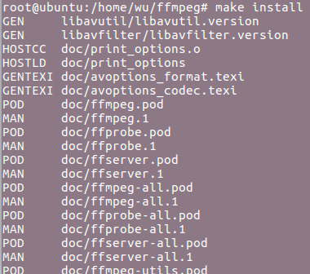
安装成功
2.5 对dehaze文件夹中的示例进行转换试验
./ffmpeg -i ~/2-wumai.mp4 -vf "dehaze" -y wumai-test.mp4
2.6 pkg-config的详细设置（环境变量）
http://blog.csdn.net/luotuo44/article/details/24836901

